Synchrotron radiation for explosion investigation

Lavrentiev Institute of Hydrodynamics, Novosibirsk, Russia
Institute of Solid State Chemistry and Mechanochemistry, Novosibirsk, Russia
Institute of nuclear physics, Novosibirsk, Russia

Abstract. This paper gives a short description of a synchrotron radiation technique application for explosion processes investigation. All presented results were obtained on accelerator facility VEPP-3 (Institute of nuclear physics, Novosibirsk, Russia).

The VEPP-3 electron-positron storage ring
The VEPP-3 storage ring (perimeter: 74.4 m, injection energy: 350 MeV, maximal energy: 2000 MeV) was built in 1967-1971 and modernized in 1986-1987 (fig. 1). Maximal electron beam current accelerated up to 2 GeV is 160 mA
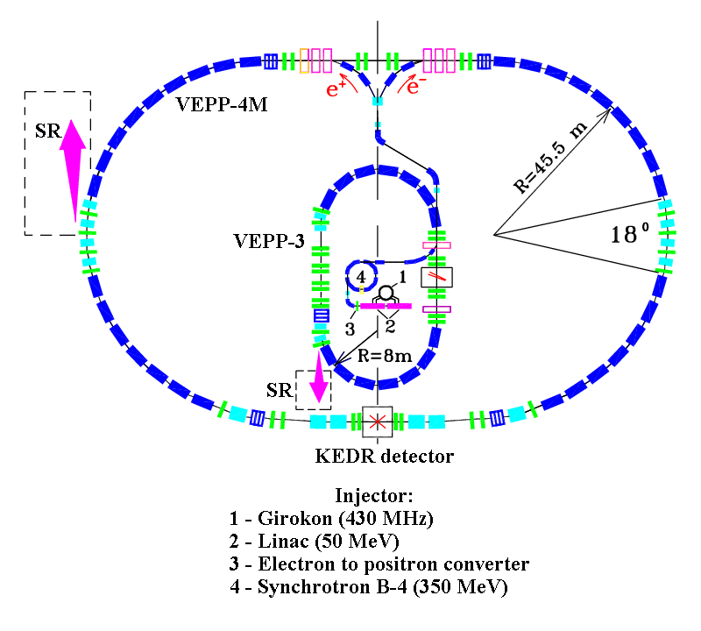
a
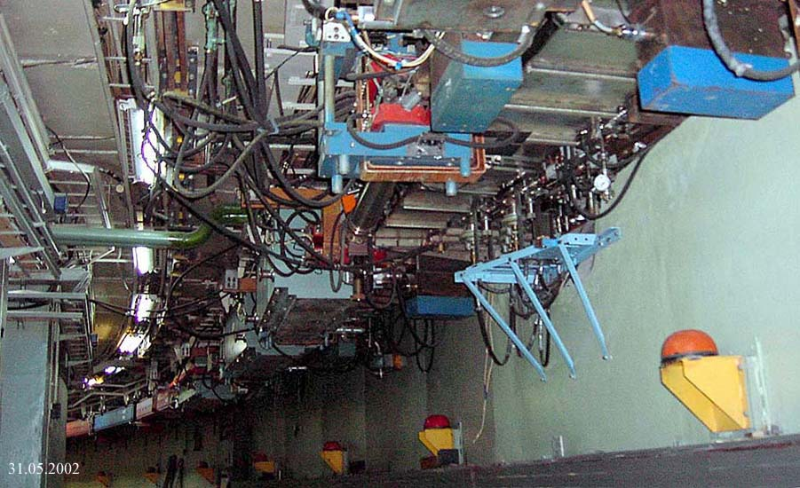
b
Fig. 1. The VEPP-3 – VEPP-4 accelerating-storage complex. a – general scheme and b –picture.

Explosion investigation station
Siberian Synchrotron Radiation Centre consist of many experimental stations suited for investigation in different science areas. One of this stations were specially developed for high velocity explosion processes investigation (figs. 2, 3).
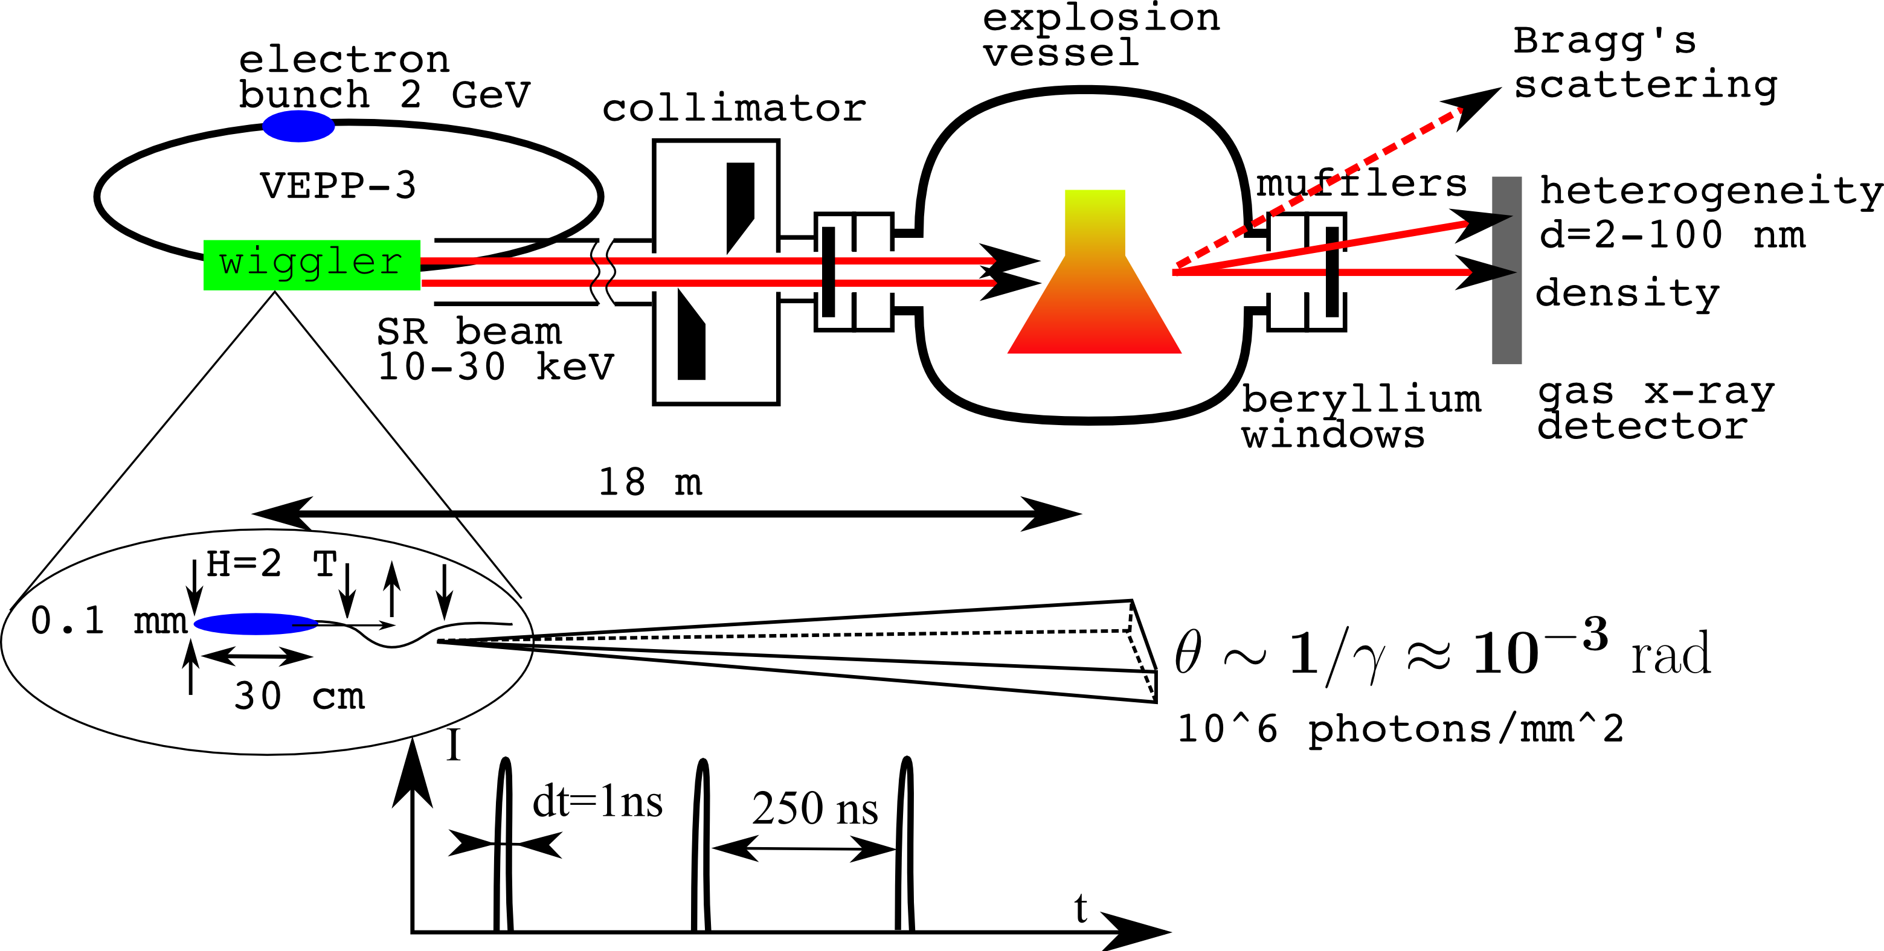
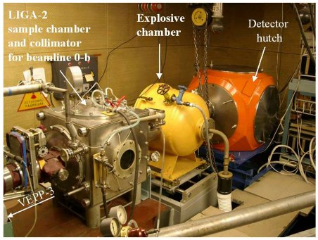
Fig. 2. Explosion experiments scheme and picture of real device.
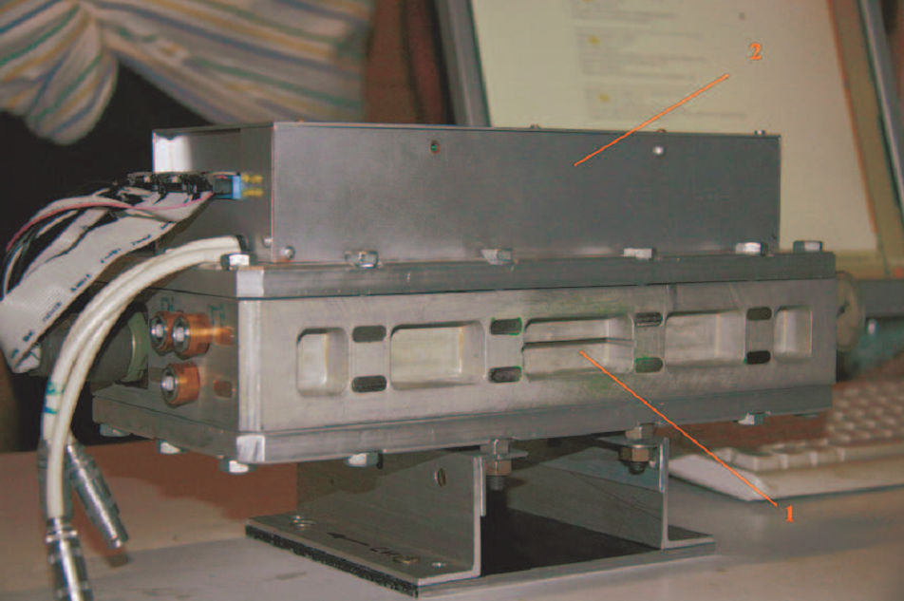
Fig. 3. General view and properties of x-ray detector DIMEX-3. 1 – entrance slit, 2 – electronic block.Strip size – 100 mkm, number of space channels – 512, number of time frames – 32, shortest exposition – 125 нс.
X-ray computer tomography
Synchrotron radiation allows one to implement a nonperturbing internal method for measuring the spatial density distribution of detonation products of condensed HEs.
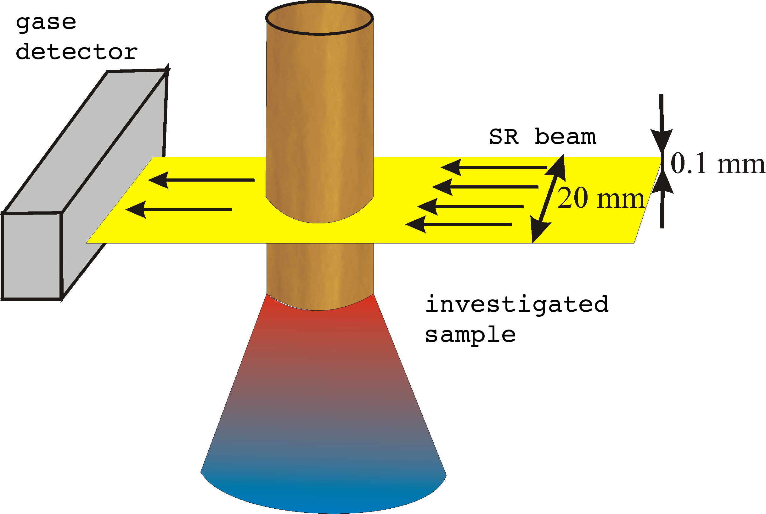
Fig. 4. General scheme for tomography experiments.
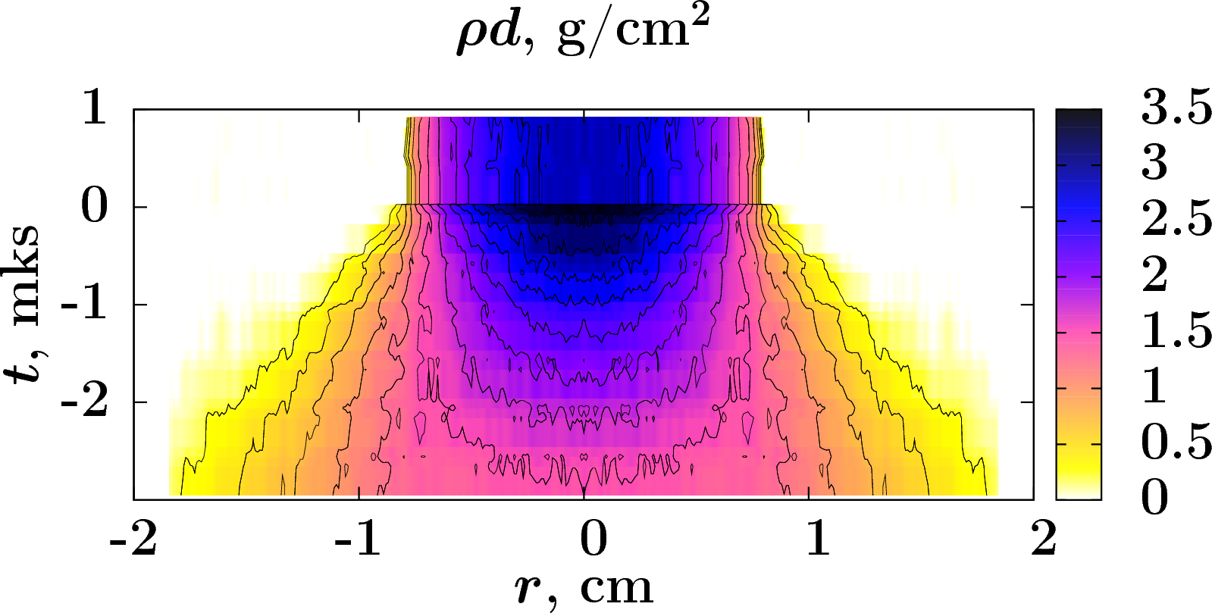
Fig. 5. Detonation of cylindrical sample of TNT50%+RDX50% mixture. Areal density.
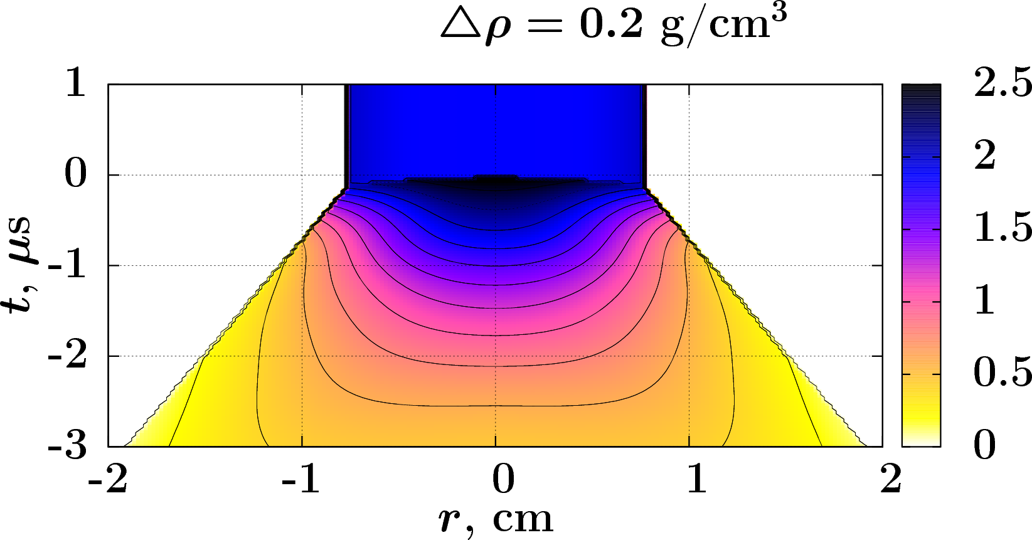
Fig. 6. Volume density after Abel inversion.
Dynamics of nanostructures formation.
For the time being, kinetics of condensed carbon nanoparticles formation at detonation of high explosives can be experimentally registered only through diffraction methods using synchrotron radiation (SR).
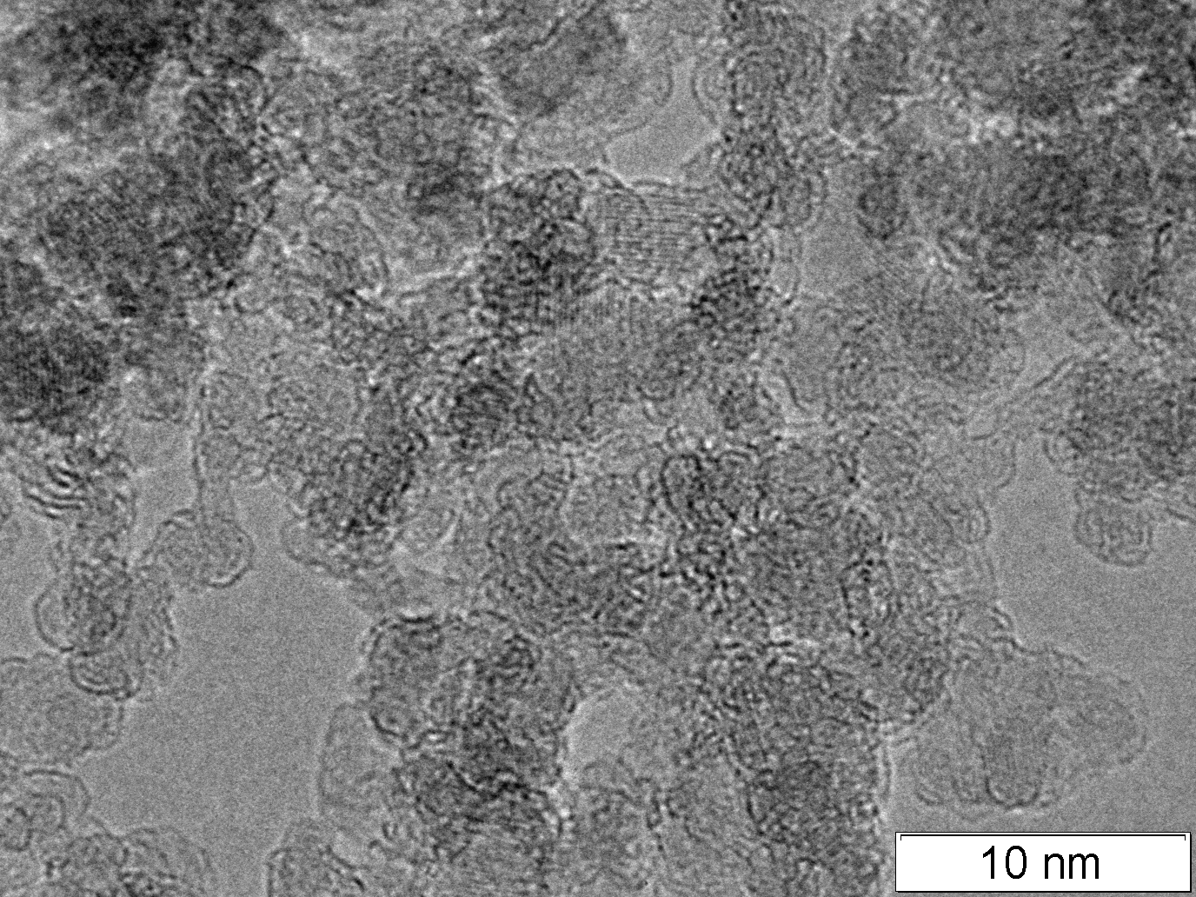
Fig. 7. Detonation nanodiamonds.

Application of highly-periodic SR to measuring small angle x-ray scattering (SAXS) (fig. 8) makes it possible to trace the development of signal in the course of detonation of high explosives. Analysis of the development allows estimating the amount (fig. 9) and sizes (fig. 10) of the resulting particles of condensed carbon as well as size variations in time after the detonation wave has passed.

Detonation products
Sample of HE
SR
detector DIMEX
SAXS
Fig. 8. General scheme for SAXS measurements.

Fig. 9. Integral SAXS dynamics at detonation processes. B – TNT/RDX 70/30, C – TNT/RDX 50/50, D – TNT (ρ = 1,6), E – TNT/RDX 60/40, F – RDX.
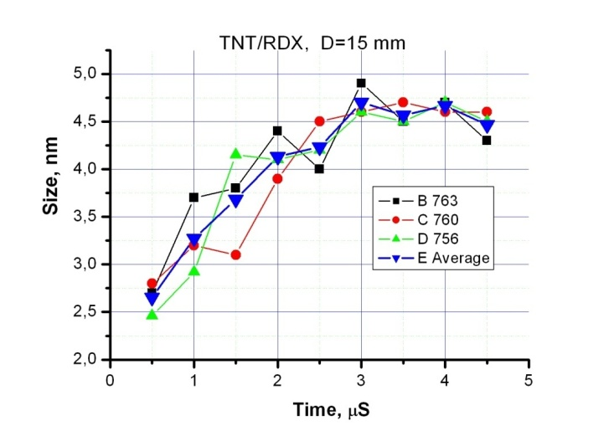
Fig. 10. Dynamics of the average particle size.
Shock waves experiments
Specially development short explosive gun can drives metal plunger with velocities 1—3 km/s. This plungers allows to carry out shock waves experiments with accurate loading of investigated sample.
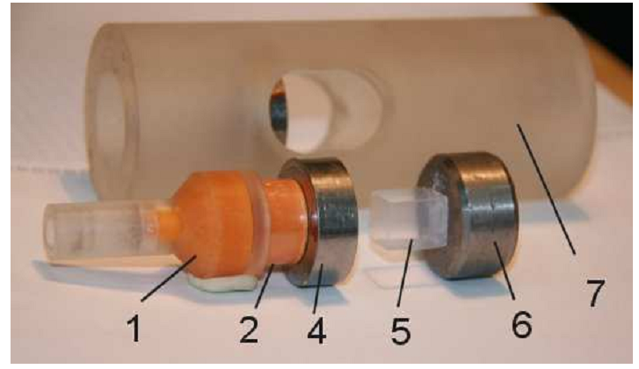
Fig. 11. Picture of assembly for sock wave compression of aerogel sample. 1 – explosion lens, 2 – HE, 4 – guard ring with aluminum flayer, 5 – investigated sample of silica aerogel ($ρ=0\text{.}\text{25}$ g/cc), 6 – base of sample, 7 – case of assembly.
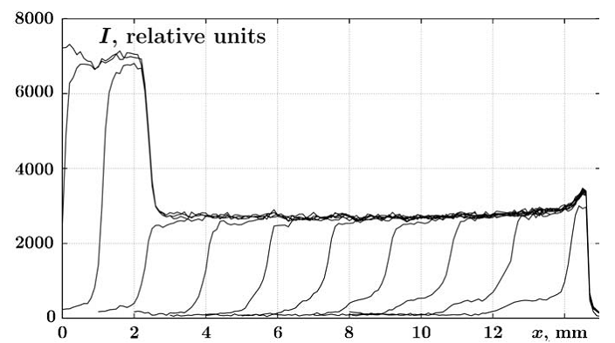
Fig. 12. Changes of the relative intensity of transmitted radiation while the shock wave propagates along sample.
Deflagration to detonation transition
Developed technique can be applied to nonstationary processes. For example, for detonation initiation.
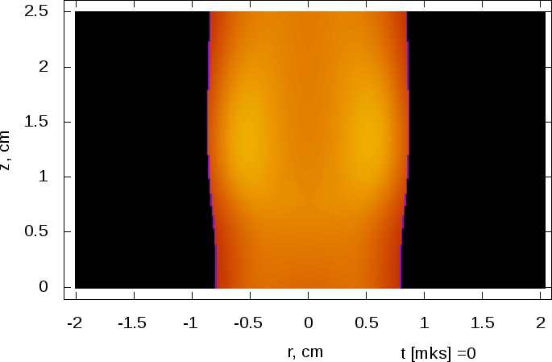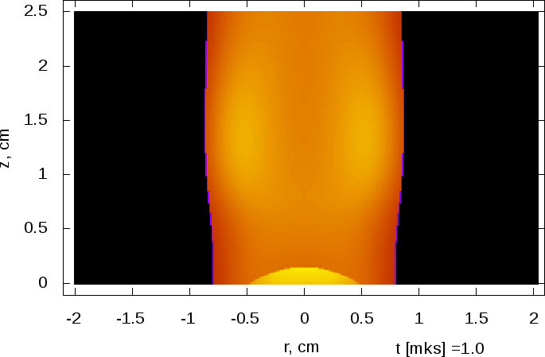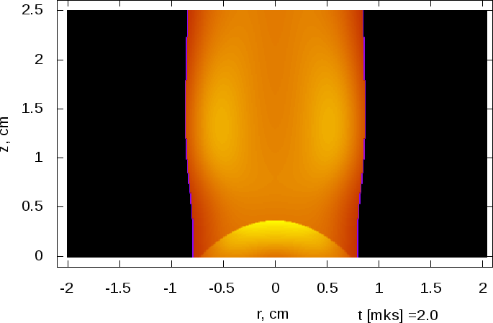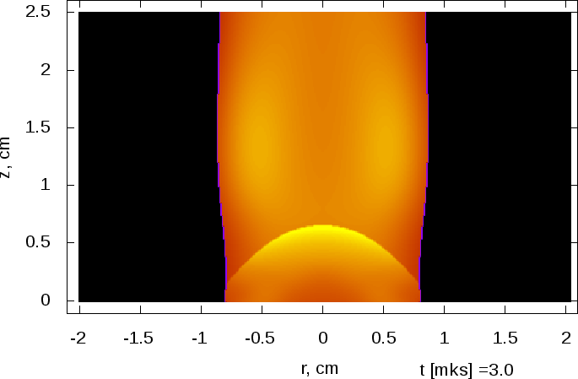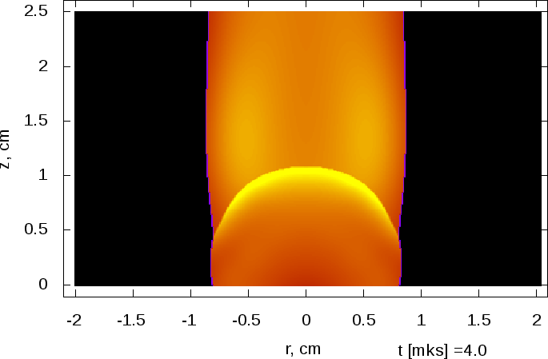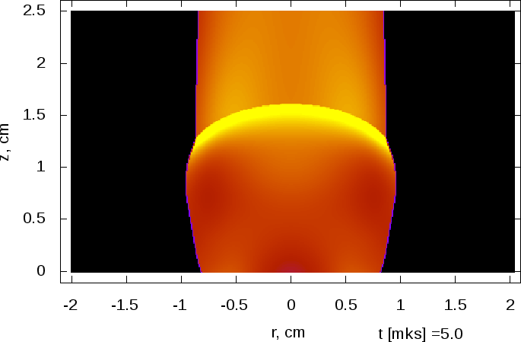

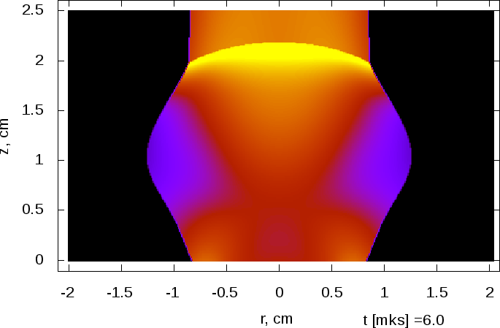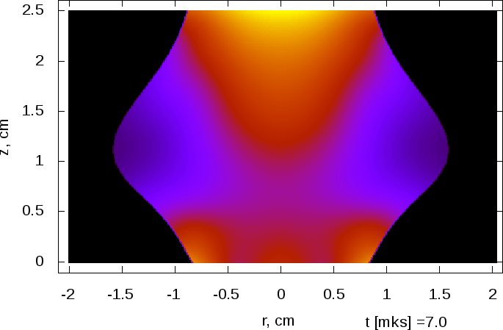
Fig. 13. Density distribution at various times. Initiation of porous petn with gravity density 1 g/cc by intensive hot gas flow.
Bibliography
  - X-ray transmission tomography for detonation investigation. E.R. Pruuel, K.A. Ten, V.M. Titov, L.A. Lukianchikov, L.A. Merzhievsky, P.I. Zubkov, B.P. Tolochko, I.L. Zhogin, V.V. Zhulanov, V.M. Aulchenko, L.I. Shekhtman.
14th International Detonation Symposium. pdf
  - Measurements of SAXS signal during TATB detonation using synchrotron radiation. Ten K.A., Titov V.M., Pruuel E.R., Lukyanchikov L.A., Tolochko B.P., Zhogin I.L. Aminov Yu.A., Filin V.P., Loboyko B.G., Muzyrya A.K., Smirnov E.B. 14th International Detonation Symposium. doc
  - Tomography of the flow of detonation products using SR. K.A. Ten, E.R. Pruuel, L.А. Merzhievsky, L.A. Lukjanchikov, B.P. Tolochko, I.L. Zhogin, L.I. Shekhtman.
Nuclear Instruments and Methods in Physics Research A 603 (2009) 160--163. pdf
  - Synchrotron radiation as a tool to construct the shock adiabats of aerogel. L.А. Merzhievsky, E.V. Bespalov, V.P. Efremov, L.A. Lukianchikov, E.R. Pruuel, K.A. Ten, V.M. Titov, B.P. Tolochko, V.E. Fortov, M.R. Sharafutdinov. Nuclear Instruments and Methods in Physics Research A 603 (2009) 164--166. pdf
  - Current status and further improvements of the detector for imaging of explosions. V.M. Aulchenko, O.V. Evdokov, L.I. Shekhtman, K.A. Ten, B.P.Tolochko, I.L. Zhogin, V.V. Zhulanov. Nuclear Instruments and Methods in Physics Research, ISSN 0168-9002, Section A, Vol. 603, Issue 1-2, 2009, pp. 73-75. pdf
  - Full bibliography of project http://ancient.hydro.nsc.ru/srexpl
July 21, 2011

